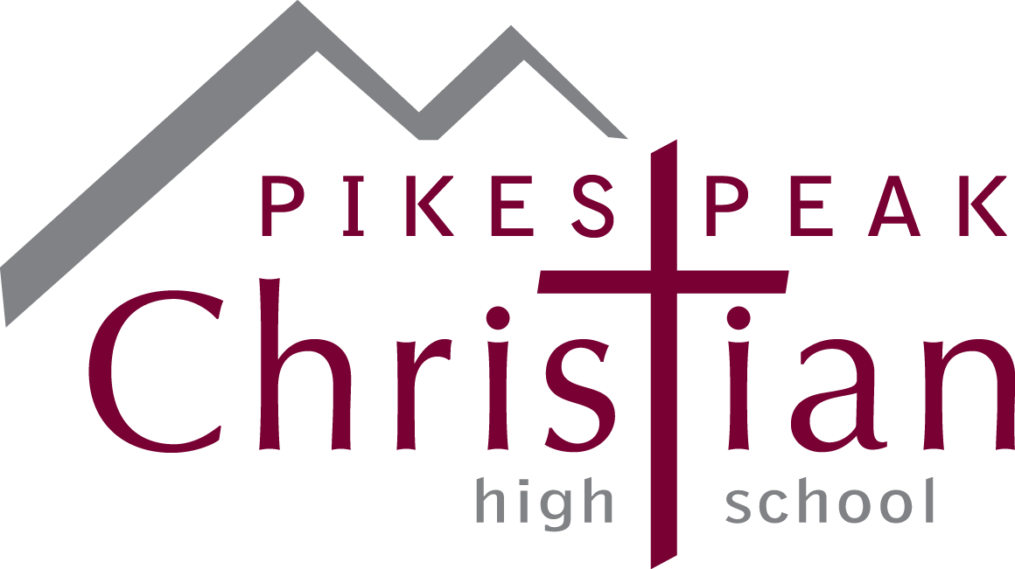

2023 Fine Arts Scholarship Program

Guidelines

Pikes Peak Christian High School Fine Arts Department announces the 2023 Fine Arts Scholarship Program. Under this program there is one (1) $500 scholarship that will be awarded to a member of the Pikes Peak Christian High School’s senior class. All senior students who have been involved in Fine Arts (art, music, band, photography, graphics design, drama, etc.) are eligible to apply.

Program Guidelines & Priorities:
* Seeking graduating seniors with an interest and involvement in the Fine Arts Program during their high school career at PPCS.
* Applicants must have a plan to attend a 2 or 4 year college or technical school.
* Scholarship funds will be paid in December 2023 or January 2024 for the second semester of the student’s first year directly to the college and not to the student. It will be the student’s responsibility to submit to PPCS at that time an invoice for second semester tuition and fees, student ID number and college information.
* Application should be filled out in Microsoft WORD (including essay) and then submitted by email to FineArtsScholarship@ppcseagles.org with a deadline of Friday, April 21, by 4:00 p.m. (Handwritten applications will not be accepted.)
* Late applications will not be accepted.
* Preference may be given to students pursuing a fine arts major, but this will only be a secondary factor. The primary determinant will be involvement in the arts while attending PPCS.

The applications will be reviewed and recipients selected by a committee consisting of Pikes Peak Christian Fine Arts Department staff members. The scholarship will be awarded at FAB in May 2023.
Applications may be downloaded at http://www.ppcseagles.org/high-school/HS-Fine-Arts.cfm.

FINE ARTS Scholarship APPLICATION 2023

Please type your answers.
1. | Last Name: | First Name:
2. | Cumulative Weighted Grade Point Average (GPA): __________ (On a 4.0 scale)
3. | List any academic honors, awards and membership activities while in high school:
4. | List your hobbies, outside interests, extracurricular activities and school related volunteer activities:
5. | List your non-school sponsored volunteer activities in the community:
6. | A. If you have decided on what college you will attend, please list school name:  B. If not, list your top 3 college choices:
7. | A. If you have decided, list major you plan on pursuing:  B. If not, list your top 3 choices:

8. On the last page of this application, please write a well-written essay (250 - 500 words) answering the following:

Describe how being involved in Fine Arts has shaped who you are today and what it has taught you. Also, discuss how that involvement will help you succeed in college and beyond.

STATEMENT OF ACCURACY FOR STUDENTS

I hereby affirm that all the above stated information provided by me is true and correct to the best of my knowledge. I also consent that if chosen as a scholarship winner my picture may be taken and used to promote the Pikes Peak Christian High School’s Fine Arts Scholarship Program. (Winner may waive photo due to unusual or compelling circumstances.)

I hereby understand that if chosen as a scholarship winner, according to PPCS Fine Arts Scholarship policy, it is my responsibility to remit to PPCS the appropriate information for my scholarship to be paid directly to my educational institution for my second semester in December 2023/January 2024.

I hereby understand that incomplete applications or applications that do not meet eligibility criteria will not be considered for this scholarship.

Signature of scholarship applicant: ___________________________________ Date: ___________________

Fine Arts Scholarship Application Essay:

